**ENTERTAINMENT**

* 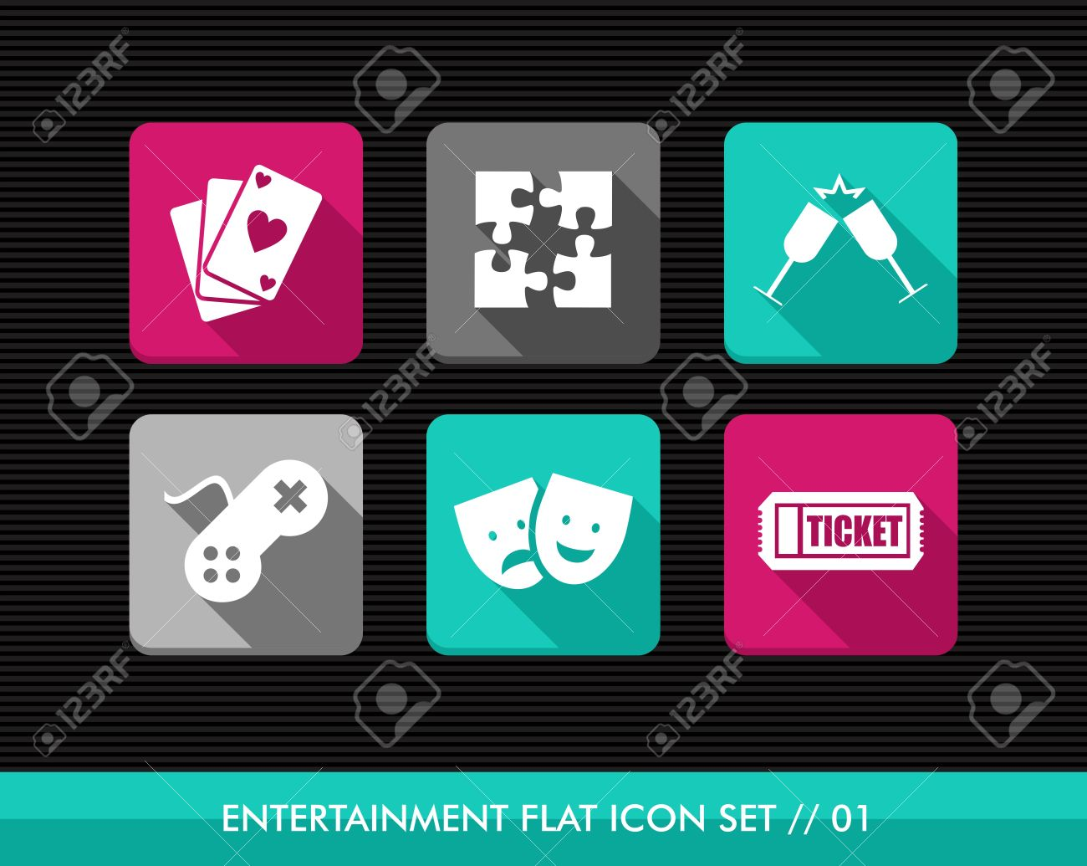Entertainment is the action of providing or being provided with amusement or enjoyment or pleasure from playing a game or watching a performer etc.
* The entertainment industry has grown immensely, from movies, tv shows, games, radio etc. Today anyone who has access to the internet is able to get to any of these forms of entertainment.
* Our ***Personal*** lives have been affected in a large way, back then television was in black and white and a certain program was not aired until a certain time so you would have to wait until it is showing, now we are able to get all of our favorite shows and movies online, the latest and also live streaming of shows. This has enabled people to watch whatever they want at any time.
* ***Socially*** all the activities that were done before the introduction of online streaming, before people would meet up with their friends to find ways of keeping themselves for example movie theaters, music concerts, on-stage plays etc. but since all of these forms of entertainment can be found on the internet most people enjoy all of this in the comfort of their homes.
* Despite the fact that we are not spending time with our friends physically, since the introduction of online gaming there has been a large number of children between the ages of 10 and above interacting with very many people around the world and also locally. This has created a large platform for children who are interested in these games for example the introduction of events e.g. comi-cons and fairs, where the designers of the games are able to showcase their newly released games and have challenges where people are able to win prizes.
* Well in our ***professional life*** this has affected us both positively and negatively. Because while people take breaks as they work they are able to relax their mind by watching some online videos for example [www.youtube.com](http://www.youtube.com), loads of videos which take your mind off work and reduce stress levels. But again streaming can have very negative effects on the employees for example getting addicted and unnecessarily continue with the entertainment and therefore disrupting them from working.
* Another major issue that has really young children, they are able to gain access to explicit material and with the entertainment industry growing very fast it raises piracy issues.